

**SIMATS SCHOOL OF ENGINEERING**

**SAVEETHA INSTITUTE OF MEDICAL AND TECHNICAL SCIENCES**

**CHENNAI-602105**

**Online Tollgate Application**

**A CAPSTONE PROJECT REPORT**

*Submitted in the partial fulfillment for the award of the degree of*

**CSA4309 INTERNET PROGRAMMING FOR WEB SERVICES**

**IN**

**COMPUTER SCIENCE AND ENGINEERING**

**Submitted by**

**K. Tejaswi Reddy**

**(192371036)**

**Under the Supervision of**

**Reetha L**

**MAY 2025**

**DECLARATION**

We, **K. Tejaswi Reddy** student of **Bachelor of Engineering in CSE**, Department of Computer Science and Engineering, Saveetha Institute of Medical and Technical Sciences, Saveetha University, Chennai, hereby declare that the work presented in this Capstone Project Work entitled **Toll Gate Application** is the outcome of our own bonafide work and is correct to the best of our knowledge and this work has been undertaken taking care of Engineering Ethics.

**K. Tejaswi Reddy**

**(192371036)**

**CERTIFICATE**

This is to certify that the project entitled **“Online Tollgate Application”** submitted by **K. Tejaswi Reddy** has been carried out under my supervision. The project has been submitted as per the requirements in the current semester of B.E. Computer Science Engineering.

Supervisor

L.Reetha

**TABLE OF CONTENTS**

|  |  |  |
| --- | --- | --- |
| **S.NO** | **TOPICS** | **Page No** |
| 1 | Abstract | 5 |
| 2 | Introduction | 6 |
| 3 | Project Description | 7 |
| 4 | Problem Description | 7-8 |
| 5 | Tool Description | 8-9 |
| 6 | Operations | 9-10 |
| 7 | Module Description | 10-11 |
| 8 | Implementation | 11-22 |
| 9 | Result | 22-26 |
| 10 | Conclusion   * Future Enhancements | 27 |
| 11 | References | 28 |

**ABSTRACT**

"Online Tollgate Application" is a user-centric web application designed for efficient management. Developed using Visual Studio for frontend development and powered by XAMPP with PHP for backend operations, the platform offers users a streamlined experience to make tollgate payments easily. Users can go through the website before reaching the tollgate and can make payments through online. The application supports comprehensive details of the passenger passing through the tollgate and it also provides a search space to find the passengers based on date, vehicle, toll amount.

With a focus on user engagement and intuitive navigation, "Online tollgate Application" facilitates seamless interaction through a user-friendly interface. By integrating frontend technologies for a responsive design and backend functionalities for robust data management, "Online Tollgate Application" aims to help the users easily to pass the tollgate without traffic.

**INTRODUCTION**

The Online Toll Gate Application is designed to simplify and streamline the toll payment process, providing users with a convenient and efficient way to manage toll transactions online. The application offers a user-friendly interface where vehicle owners can register their vehicles, make toll payments, and search for transaction records based on various criteria such as vehicle type, toll amount, and date. The primary objectives of this application are to enhance convenience, improve efficiency, ensure accessibility, maintain comprehensive transaction records, and provide a smooth user experience.

Developed using HTML, CSS, JavaScript for the frontend, PHP for the backend, and MySQL for the database, the Online Toll Gate Application integrates various functionalities to meet user needs. Key features include secure online toll payment processing, advanced search options for filtering transactions, and administrative tools for managing user data and records. The development process involved requirement analysis, design, implementation, testing, and deployment, ensuring a robust and reliable application.

The Online Toll Gate Application aims to revolutionize toll payment systems by offering a seamless and efficient solution, eliminating the need for physical toll transactions and enhancing the overall travel experience. This modernized approach not only saves time but also reduces congestion at toll booths and improves traffic flow. By leveraging web technologies, the application provides a comprehensive platform for users to manage toll payments conveniently from anywhere with an internet connection.

**PROJECT DESCRIPTION**

The Online Toll Gate Application streamlines toll payments by offering a user-friendly web interface for vehicle registration, payment processing, and transaction record searching. The application includes:

#### Proposed Method

* **Frontend Development**: Utilizing Visual Studio for designing responsive and intuitive user interfaces.
* **Backend Development**: Using XAMPP stack (Apache, MySQL, PHP) to handle server-side scripting, database management via phpMyAdmin, and ensuring secure data storage and retrieval.

**PROBLEM DESCRIPTION**

**Existing System**

The existing manual toll payment systems are fraught with inefficiencies that impede smooth travel experiences for commuters. Long wait times at toll booths are a common problem, as the manual process of collecting tolls slows down traffic flow and leads to extended queues. This not only causes delays but also results in increased fuel consumption and higher emissions due to idling vehicles, contributing to environmental pollution.

Moreover, manual toll collection systems are prone to human errors, which can lead to incorrect toll charges, disputes, and potential revenue losses for toll authorities. The lack of a streamlined record-keeping system further complicates the resolution of such issues, making it difficult to track payments and manage transaction records effectively. Additionally, the limited payment options available in traditional systems can be inconvenient for users who prefer cashless transactions.

These challenges highlight the need for a more efficient, reliable, and user-friendly solution that can enhance the toll payment experience. By adopting an online toll gate application, these problems can be mitigated, ensuring faster processing times, reducing errors, and providing a more convenient and eco-friendly toll payment system.

**Proposed System**

The proposed Online Toll Gate Application is designed to enhance efficiency and user convenience by enabling secure online toll payments and vehicle management. Users can register vehicles, pay toll fees, and access detailed reports of transactions, with toll amounts automatically calculated based on vehicle type. The system features user registration and authentication, ensuring secure access and data protection. It includes a responsive design for compatibility across devices and utilizes a robust architecture with a MySQL database, PHP for server-side processing, and HTML, CSS, and JavaScript for a user-friendly interface. This centralized platform will streamline toll collection, reduce time spent at toll gates, and offer a secure, modern solution for toll management.

1. **TOOL DESCRIPTION**

#### Hardware and Software Tools

To develop and deploy the online tollgate web application, the following hardware and software tools were utilized:

**Hardware Specifications**

* **Laptop Model**: LENOVO LOQ
* **Graphics Card**: NVIDIA GeForce RTX 3050, 6GB
* **Storage**: 500GB SSD
* **RAM**: 16GB
* **Processor**: 12th Gen Intel(R) Core(TM) i5-12450H 2.00 GHz

**Software Tools**

* **Visual Studio Code**: An integrated development environment (IDE) used for writing and debugging code. Its extensions and integrated terminal enhanced the coding experience.
* **XAMPP**: A free and open-source cross-platform web server solution stack package developed by Apache Friends. It provided the necessary Apache, MySQL, PHP, and Perl support for local development and testing.
* **phpMyAdmin**: A free software tool written in PHP, intended to handle the administration of MySQL over the web. phpMyAdmin was used for database management, allowing for easy handling of the MySQL database used in the application.
* **Google Chrome**: The primary web browser used for testing and debugging the web application. Developer tools in Chrome facilitated real-time inspection and modification of the front-end code.

The combination of powerful hardware and a robust set of development tools provided a conducive environment for the efficient development, testing, and deployment of the recipe management web application.

1. **OPERATIONS**

The Tollgate Application provides various operations for users to manage recipes effectively and ensure a smooth user experience. Below are the detailed operations based on the provided code and functionalities of the application:

**6.1 User Operations**

**Interacting with Toll Records**

* **View Toll Records:** Users can browse and view detailed information about toll records, including vehicle number, vehicle type, owner name, email, phone, toll amount, date, and time.
* **Search Toll Records:** Users can search for toll records by vehicle type, toll amount, or date using the search functionality.
* **Filter by Date:** Users can filter toll records to display entries from a specific date, making it easier to find relevant transactions.

**Taking Actions on Toll Records**

* **Submit Toll Record**: Users can submit their toll records through an online form by providing details such as vehicle number, vehicle type, owner name, email, phone, toll amount, date, and time. The records are then stored in the system's database for future reference and processing.
* **Search Toll Records**: Users can utilize the search functionality to find specific toll records based on criteria such as vehicle type, toll amount, or date. This feature helps users quickly locate and review relevant toll transactions.
* **Filter by Date**: Users can filter toll records to display entries from a specific date. This feature enhances the usability of the application by allowing users to focus on toll records from a particular timeframe, aiding in better record management and analysis.

By structuring the operations around these roles, the Online Toll Gate Application provides a seamless and efficient way for users to manage toll records and for administrators to maintain an organized and user-friendly toll payment system.

**MODULE DESCRIPTION**

To develop the Toll gate Application, we will divide the project into distinct modules, each responsible for specific functionalities. By creating individual functions for every operation and unifying them, we can ensure modularity, maintainability, and scalability.

#### Modules and Functionalities

### 7.1 Interaction Module (User)

**Function: Home Page**

* **Description:** Provides users with an introductory message about the online toll gate application.
* **Functionalities:**
* Display a welcome message with brief information about the application.
* Include a call-to-action button to apply for toll.

**Function: About Us Page**

* **Description:** Provides detailed information about the online toll gate application and its mission.
* **Functionalities:**
  + Display information about the purpose and benefits of the toll gate application.
  + Include background details and objectives.

**Function: Contact Form**

* **Description:** Allows users to send inquiries or feedback through a contact form.
* **Functionalities:**
  + Input fields for name, email, subject, and message.
  + Validate and submit the contact form to the server.

**Function: Search Toll Records**

* **Description:** Enables users to search for specific toll records based on criteria such as vehicle type, toll amount, or date.
* **Functionalities:**
  + Filter and display toll records based on search input.
  + Dynamically update the search results as the user types or selects criteria.

**IMPLEMENTATION:**

### HOME PAGE CODE:

<!DOCTYPE html>

<html>

<head>

    <title>Online Toll Gate Application - Home</title>

    <style>

        @import url('https://fonts.googleapis.com/css2?family=Roboto:wght@400;700&display=swap');

        body {

            font-family: 'Roboto', sans-serif;

            background-image: url('background.jpg');

            background-size: cover;

            background-repeat: no-repeat;

            background-attachment: fixed;

            background-position: center;

            margin: 0;

            padding: 0;

            color: white;

            display: flex;

            flex-direction: column;

            height: 100vh;

            animation: fadeIn 2s ease-in;

        @keyframes fadeIn {

            from { opacity: 0; }

            to { opacity: 1; }

        }

        .navbar {

            background-color: rgba(0, 0, 0, 0.7);

            padding: 10px 20px;

            display: flex;

            justify-content: space-between;

            align-items: center;

        }

        .navbar a {

            color: white;

            text-decoration: none;

            margin: 0 10px;

            position: relative;

            overflow: hidden;

        }

        .navbar a::after {

            content: '';

            position: absolute;

            left: 0;

            bottom: 0;

            width: 100%;

            height: 2px;

            background-color: white;

            transform: scaleX(0);

            transition: transform 0.3s ease;

        }

        .navbar a:hover::after {

            transform: scaleX(1);

        }

        .container {

            flex: 1;

            display: flex;

            flex-direction: column;

            justify-content: center;

            align-items: center;

            text-align: center;

            background-color: rgba(224, 63, 63, 0.5);

            padding: 20px;

            border-radius: 8px;

            margin: 20px;

            animation: slideIn 1s ease-in-out;

        }

        @keyframes slideIn {

            from { transform: translateY(100px); }

            to { transform: translateY(0); }

        }

        h1 {

            font-size: 3em;

            margin-bottom: 20px;

            animation: bounceIn 1.5s ease;

        }

        @keyframes bounceIn {

            0%, 20%, 50%, 80%, 100% {

                transform: translateY(0);

            }

            40% {

                transform: translateY(-30px);

            }

            60% {

                transform: translateY(-15px);

            }

        }

        p {

            font-size: 1.5em;

            margin-bottom: 20px;

        }

        .navbar a:hover {

            color: #ffcc00;

        }

        .cta-button {

            padding: 10px 20px;

            background-color: #5cb85c;

            color: white;

            border: none;

            border-radius: 4px;

            cursor: pointer;

            font-size: 1.2em;

            transition: background-color 0.3s, transform 0.3s;

        }

        .cta-button:hover {

            background-color: #4cae4c;

            transform: scale(1.05);

        }

    </style>

</head>

<body>

    <div class="navbar">

        <div class="nav-links">

            <a href="home.html">Home</a>

            <a href="about.html">About</a>

            <a href="contact.html">Contact</a>

            <a href="search.html">Search</a>

        </div>

    </div>

    <div class="container">

        <h1>Online Toll Gate Application</h1>

        <h1>Welcome to Bangalore</h1>

        <p>Your easy and convenient way to pay tolls online.</p>

        <button class="cta-button" onclick="window.location.href='tollgate.html'">Apply for Toll</button>

    </div>

</body>

</html>

**DATABASE RETRIVAL:**

<?php

// Database configuration

$servername = "localhost:3306";

$username = "root";

$password = "";

$dbname = "tollgate";

// Create connection

$conn = new mysqli($servername, $username, $password, $dbname);

// Check connection

if ($conn->connect_error) {

    die("Connection failed: " . $conn->connect_error);

}

// Retrieve form data

$vehicle_type = isset($_POST['vehicle_type']) ? $_POST['vehicle_type'] : '';

$toll_amount = isset($_POST['toll_amount']) ? $_POST['toll_amount'] : '';

$search_date = isset($_POST['search_date']) ? $_POST['search_date'] : '';

// Create SQL query based on form data

$sql = "SELECT * FROM users WHERE 1=1";

if (!empty($vehicle_type)) {

    $sql .= " AND vehicle_type = '$vehicle_type'";

}

if (!empty($toll_amount)) {

    $sql .= " AND toll_amount = '$toll_amount'";

}

if (!empty($search_date)) {

    $sql .= " AND date = '$search_date'";

}

// Execute query

$result = $conn->query($sql);

?>

<!DOCTYPE html>

<html lang="en">

<head>

    <meta charset="UTF-8">

    <meta name="viewport" content="width=device-width, initial-scale=1.0">

    <title>Search Results - Online Toll Gate Application</title>

    <style>

        body {

            font-family: 'Times New Roman', Times, serif;

            background-image: url('background.jpg');

            background-size: cover;

            background-repeat: no-repeat;

            background-attachment: fixed;

            background-position: center;

            margin: 0;

            padding: 0;

            color: white;

            display: flex;

            flex-direction: column;

            height: 100vh;

        }

        .navbar {

            background-color: rgba(0, 0, 0, 0.7);

            padding: 10px 20px;

            display: flex;

            justify-content: space-between;

            align-items: center;

        }

        .navbar a {

            color: white;

            text-decoration: none;

            margin: 0 10px;

            transition: color 0.3s ease-in-out;

        }

        .navbar a:hover {

            color: #ffcc00;

            text-decoration: underline;

        }

        .container {

            flex: 1;

            display: flex;

            flex-direction: column;

            justify-content: center;

            align-items: center;

            text-align: center;

            background-color: rgba(224, 63, 63, 0.5);

            padding: 20px;

            border-radius: 8px;

            margin: 20px;

            animation: fadeIn 2s;

        }

        table {

            width: 100%;

            border-collapse: collapse;

            margin-top: 20px;

            background-color: white;

            color: black;

        }

        th, td {

            padding: 10px;

            border: 1px solid #ccc;

            text-align: center;

        }

        th {

            background-color: #333;

            color: white;

        }

        @keyframes fadeIn {

            from { opacity: 0; }

            to { opacity: 1; }

        }

        button {

            padding: 10px 15px;

            background-color: #5cb85c;

            color: white;

            border: none;

            border-radius: 4px;

            cursor: pointer;

        }

        button:hover {

            background-color: #4cae4c;

        }

        .button-container {

            display: flex;

            justify-content: space-between;

        }

    </style>

</head>

<body>

    <div class="navbar">

        <div class="nav-links">

            <a href="home.html">Home</a>

            <a href="about.html">About</a>

            <a href="contact.html">Contact</a>

            <a href="search.html">Search</a>

        </div>

    </div>

    <div class="container">

        <h1>Search Results</h1>

        <?php if ($result->num_rows > 0): ?>

            <table>

                <thead>

                    <tr>

                        <th>Vehicle Number</th>

                        <th>Vehicle Type</th>

                        <th>Owner Name</th>

                        <th>Email</th>

                        <th>Phone</th>

                        <th>Toll Amount</th>

                        <th>Date</th>

                        <th>Time</th>

                    </tr>

                </thead>

                <tbody>

                    <?php while ($row = $result->fetch_assoc()): ?>

                        <tr>

                            <td><?php echo $row['vehicle_number']; ?></td>

                            <td><?php echo $row['vehicle_type']; ?></td>

                            <td><?php echo $row['owner_name']; ?></td>

                            <td><?php echo $row['email']; ?></td>

                            <td><?php echo $row['phone']; ?></td>

                            <td><?php echo $row['toll_amount']; ?></td>

                            <td><?php echo $row['DATE']; ?></td>

                            <td><?php echo $row['TIME']; ?></td>

                        </tr>

                    <?php endwhile; ?>

                </tbody>

            </table>

        <?php else: ?>

            <p>No results found for your search criteria.</p>

        <?php endif; ?>

        <button class="btn" onclick="window.location.href='search.html'">Back to Search</button>

    </div>

    <?php

    // Close connection

    $conn->close();

    ?>

</body>

</html>

**TOLLGATE PAGE CODE:**

<!DOCTYPE html>

<html lang="en">

<head>

    <meta charset="UTF-8">

    <meta name="viewport" content="width=device-width, initial-scale=1.0">

    <title>Online Toll Gate Application</title>

    <style>

        body {

            font-family: Arial, sans-serif;

            background-image: url("toll.jpg");

            background-size: cover;

            margin: 0;

            padding: 0;

            display: flex;

            justify-content: center;

            align-items: center;

            height: 100vh;

        }

        .container {

            background-color: white;

            padding: 20px;

            border-radius: 8px;

            box-shadow: 0 0 10px rgba(0, 0, 0, 0.1);

        }

        h1 {

            margin-bottom: 20px;

        }

        .form-group {

            margin-bottom: 15px;

        }

        label {

            display: block;

            margin-bottom: 5px;

        }

        input, select {

            width: 100%;

            padding: 8px;

            box-sizing: border-box;

            border: 1px solid #ccc;

            border-radius: 4px;

        }

        button {

            padding: 10px 15px;

            background-color: #5cb85c;

            color: white;

            border: none;

            border-radius: 4px;

            cursor: pointer;

        }

        button:hover {

            background-color: #4cae4c;

        }

        .button-container {

            display: flex;

            justify-content: space-between;

        }

    </style>

</head>

<body>

    <div class="container">

        <h1>Online Toll Gate Application</h1>

        <form action="tollgate.php" method="post">

            <div class="form-group">

                <label for="vehicle-number">Vehicle Number</label>

                <input type="text" id="vehicle-number" name="vehicle_number" required>

            </div>

            <div class="form-group">

                <label for="vehicle-type">Vehicle Type</label>

                <select id="vehicle-type" name="vehicle_type" required>

                    <option value="">Select vehicle type</option>

                    <option value="car">Car</option>

                    <option value="truck">Truck</option>

                    <option value="bus">Bus</option>

                    <option value="bike">Bike</option>

                </select>

            </div>

            <div class="form-group">

                <label for="owner-name">Owner Name</label>

                <input type="text" id="owner-name" name="owner_name" required>

            </div>

            <div class="form-group">

                <label for="email">Email</label>

                <input type="email" id="email" name="email" required>

            </div>

            <div class="form-group">

                <label for="phone">Phone</label>

                <input type="tel" id="phone" name="phone" required>

            </div>

            <div class="form-group">

                <label for="toll-amount">Toll Amount</label>

                <input type="number" id="toll-amount" name="toll_amount" required>

            </div>

            <div class="button-container">

                <button type="button" onclick="window.location.href='home.html'">Go Back</button>

                <button type="submit" class="button">Submit</button>

            </div>

        </form>

    </div>

</body>

</html>

**DATABASE CONNECTIVITY:**

<?php

error_reporting(E_ALL);

ini_set('display_errors', 1);

// Set the default timezone

date_default_timezone_set('Asia/Kolkata'); // Set to your desired timezone

// Database configuration

$servername = "localhost:3306"; // Your MySQL server name

$username = "root"; // Your MySQL username

$password = ""; // Your MySQL password

$dbname = "tollgate"; // Your database name

// Create connection

$conn = new mysqli($servername, $username, $password, $dbname);

// Check connection

if ($conn->connect_error) {

    die("Connection failed: " . $conn->connect_error);

}

// Prepare and bind

$stmt = $conn->prepare("INSERT INTO users (vehicle_number, vehicle_type, owner_name, email, phone, toll_amount, date, time) VALUES (?, ?, ?, ?, ?, ?, ?, ?)");

if (!$stmt) {

    die("Prepare failed: " . $conn->error);

}

$stmt->bind_param("ssssssss", $vehicle_number, $vehicle_type, $owner_name, $email, $phone, $toll_amount, $date, $time);

// Set parameters and execute

$vehicle_number = $_POST['vehicle_number'];

$vehicle_type = $_POST['vehicle_type'];

$owner_name = $_POST['owner_name'];

$email = $_POST['email'];

$phone = $_POST['phone'];

$toll_amount = $_POST['toll_amount'];

$date = date("Y-m-d"); // Current date

$time = date("H:i:s"); // Current time

if ($stmt->execute()) {

    // Close statement and connection

    $stmt->close();

    $conn->close();

    // Redirect after successful registration

    header("Location: tollgate.html");

    exit();

} else {

    echo "Error: " . $stmt->error;

}

// Close statement and connection

$stmt->close();

$conn->close();

?>

**RESULT**

The implementation of the Online Toll Gate Application successfully streamlined the toll payment process, providing users with a convenient and efficient method to manage toll payments and vehicle information. The system's automated toll calculation feature based on vehicle type reduced the likelihood of errors and ensured consistency in toll collection. The user-friendly interface, along with secure registration and login functionalities, enhanced user experience and security. Compatibility across various devices ensured accessibility for a broader user base. Overall, the application demonstrated improved operational efficiency, reduced congestion at toll gates, and offered a modern, reliable solution for toll management.

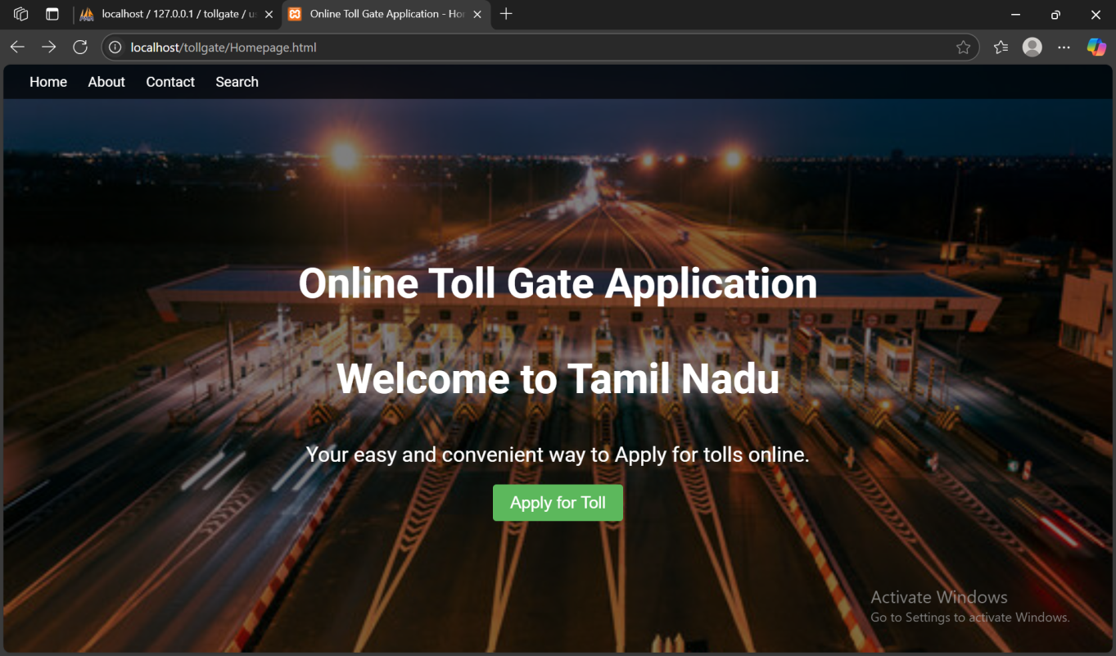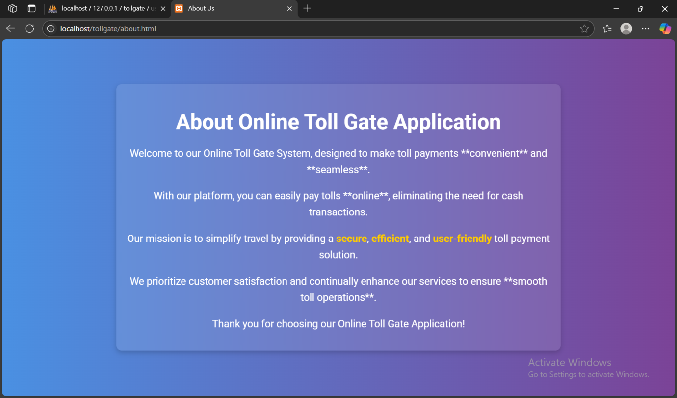**OUTPUT-**

Fig.1 Home Page

Fig.2 About Page

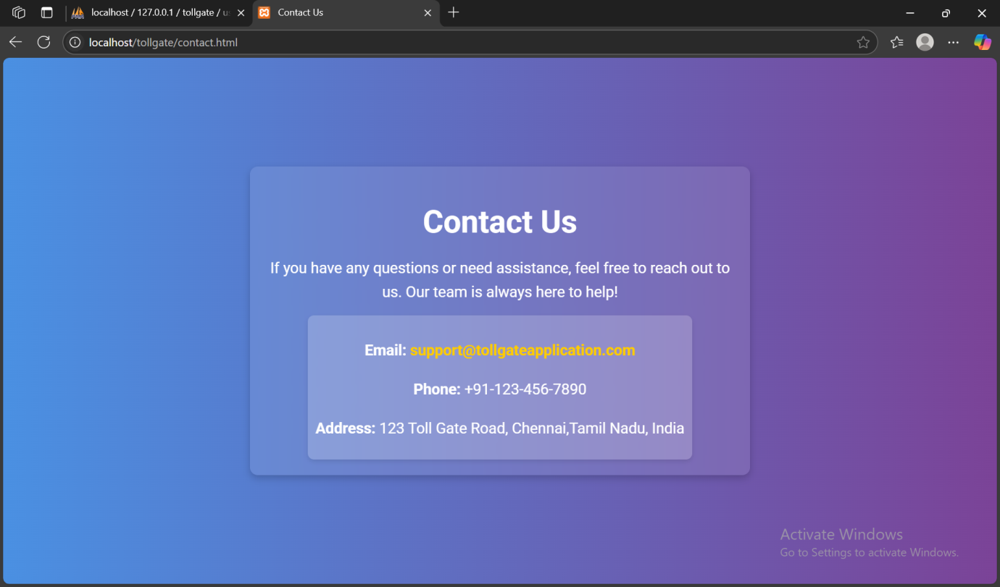Fig. 3 Contact Page

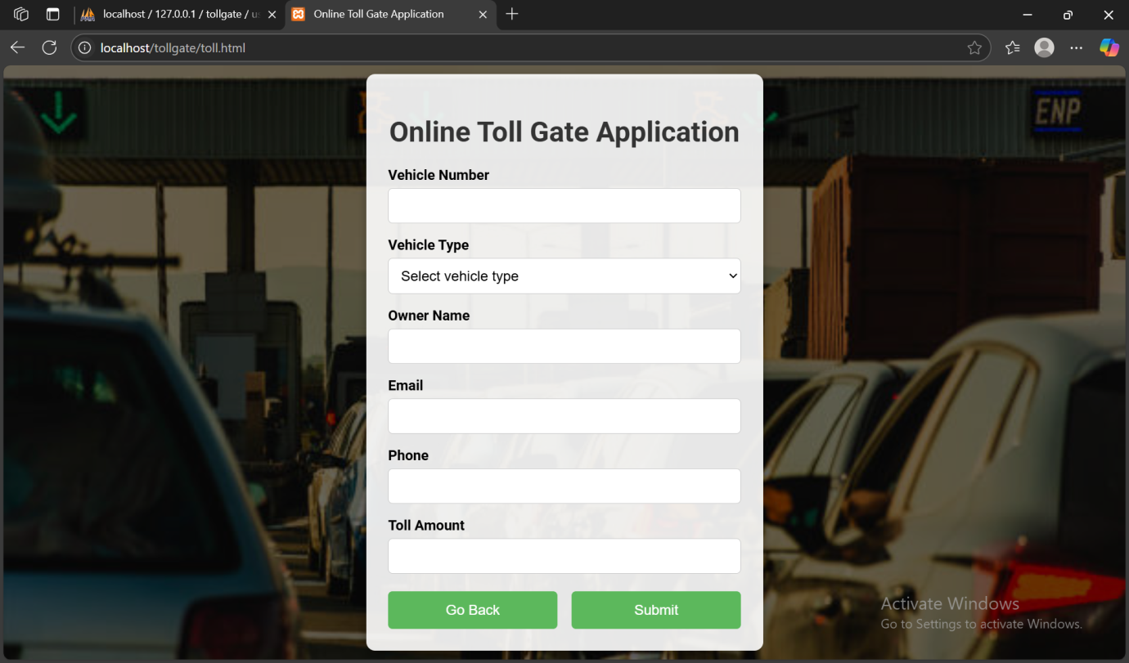Fig. 4 Application Page

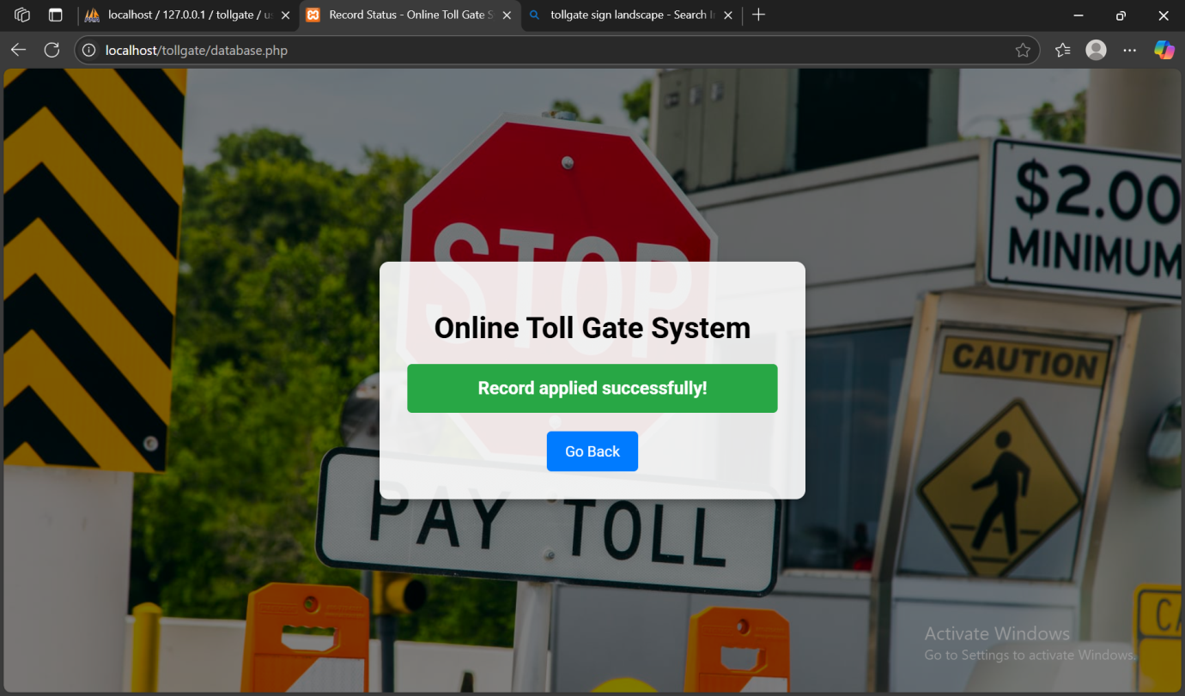Fig. 5 Result

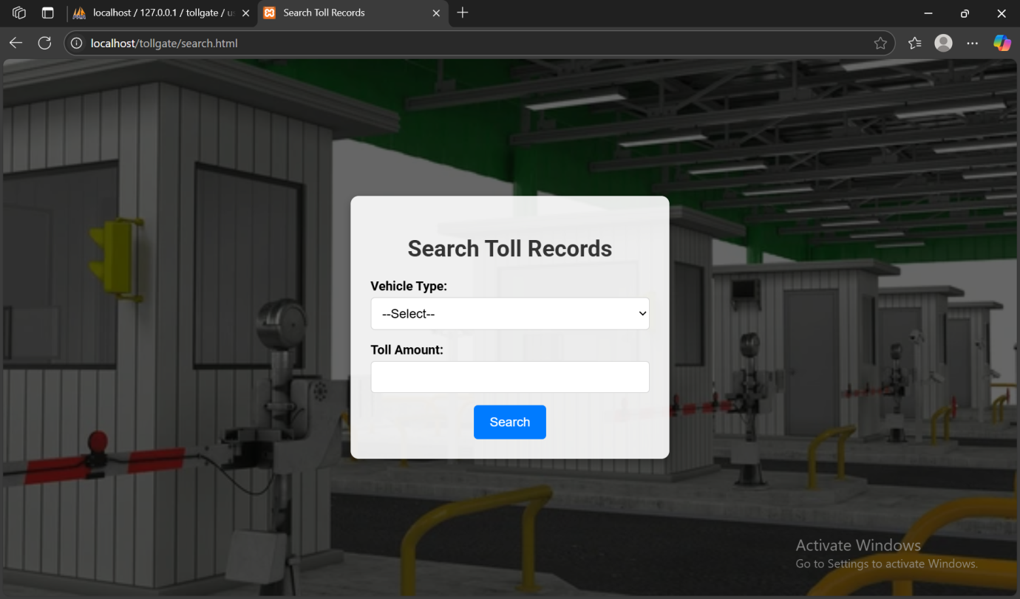

Fig.6 Search Page

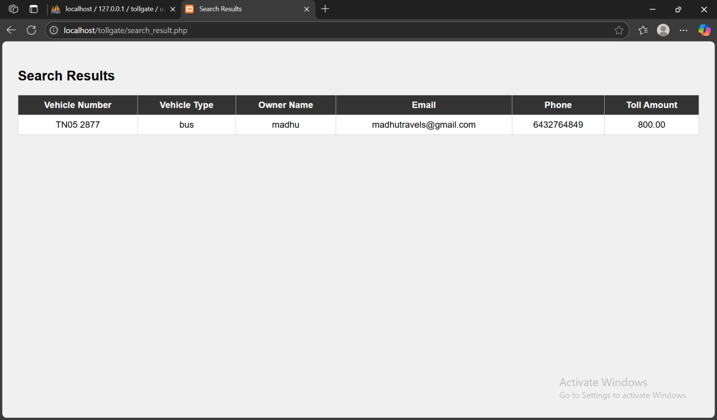Fig.7 Search Result Page

**CONCLUSION**

The "Online Tollgate Application" is a comprehensive web platform designed to streamline toll payment processes for users, allowing them to manage toll payments with ease and efficiency. Developed with a user-friendly interface, the application ensures a seamless experience for registering vehicles, making toll payments, and maintaining detailed records of transactions. By providing features such as vehicle registration, toll payment processing, and search functionalities, the application significantly reduces the time and effort associated with traditional toll payment methods, enhancing overall user convenience and satisfaction.

**FUTURE ENHANCEMENTS**

As the "Online Tollgate Application" evolves, several future enhancements can be implemented to further improve user experience and engagement. One major improvement is the integration of advanced search and filtering options. This includes allowing users to search for toll records based on specific criteria such as vehicle type, toll amount, and date range, making it easier to find relevant information quickly. Additionally, implementing real-time toll rate updates and notifications can keep users informed about any changes or promotions, enhancing the application's utility.

Another significant enhancement is the incorporation of features to boost user interaction and community engagement. Enabling users to receive digital receipts, participate in loyalty programs, and access toll history reports can add value to the user experience. Integrating the application with navigation and route planning tools can help users optimize their travel routes and toll expenses. Furthermore, implementing a secure and efficient payment gateway with multiple payment options can enhance transaction security and user trust. By continuously improving these features, the "Online Tollgate Application" can remain a reliable, efficient, and user-friendly platform for managing toll payments.

**REFERENCES**

[1] Edward B. Panganiban, Jennifer C. Dela Cruz, “RFID-Based Vehicle Monitoring System”, School of EECE, Mapua University, IEEE 2017.

[2] M. Sarbini, S. Hassan, T. Jiann, PM. Ahmad, “Design of an RFID-based speed monitoring system for road vehicles in Brunei Darussalam”, IEEE 2014, pp. 219-223.

[3] C.R. Kumar, B. Vijayalakshmi, C. Ramesh, C. Pandian, “Vehicle Theft Alarm and Tracking The Location Using RFID & GPS”, International Journal of Emerging Technology and Advanced Engineering Website: www.ijetae.com ISO Certified Journal 2013, pp. 525528.

[4] Sanchit Agarwal, Shachi Gupta, Nidheesh Sharma, “Electronic Toll Collection System Using Barcode Laser Technology”, International Journal of Emerging Trends & Technology in Computer Science (IJETTCS), Vol 3, 2014

[5] D. Kiranmayi, “Vehicle Monitoring System Using RFID”, Durugu Kiranmayi / (IJCSIT) International Journal of Computer Science and Information Technologies, Vol. 6 (3), 2016, pp. 1444-1447

[6] R. Karthikayeni1, P. KeerthikaBala2, K. Vignesh, “toll plaza payment using QR code”, International Research Journal of Engineering and Technology, 2018.

[7] Aishwarya Agarwal, “Automatic License Plate Recognition using Raspberry Pi,” IEEE International Interdisciplinary Conference on Science Technology Engineering Management Singapore, 22nd, 23rd April 2017.

[8] Persad, Khali, C. Michael Walton, and Shahriyar Hussain. Toll Collection Technology and Best Practices. No. Product 0-5217-P1. 2007.

[9] Li, Shuguang, et al. "Video-based traffic data collection system for multiple vehicle types."